**DS PROJECT**

**Pair No : 35   
 ROLL NO : 2016btecs00063  
 ROLL NO : 2016btecs000103**

**Problem statement**

* **You have been hired by a law firm that is working on a sex discrimination case. Your firm has obtained a file of income data. Input: A file, incfile, of floating point salary amounts, with one amount per line. Each amount is preceded by a character (‘F’ for female and ‘M’ for male). This code is the first character on each input line and is followed by a blank, which separates the code from the amount.**
* **Output:**
* **1. All the input data (to reprint)**
* **2. The number of females and their average income.**
* **3. The number of males and their average income**
* **. 4. The data needs to be categorized in following income slabs.**

**0-50000, 50001-100000, 100001-200000, 200001-300000, 300001-above.**

* **Show using a bar chart, the number of male and female employees in each category.**

**Algorithm**

**declaring structures for male , female and 5 salary categories**

**// In male structure there is sum for calculating salary of all men and total male count in all 5 salary categories**

**// In female structure there is sum for calculating salary of all female and total female count in all 5 salary categories**

**// In all 5 categories structures there is male count and female count in particular category**

* **int gm ;**
* **int gd = DETECT ;**
* **Initialising all the structures with zero**
* **Take a file pointer *fp**
* **Take a array of 10 elements which contain string**
* **char gen ;**
* **double sal;**
* **Open the file Incfile.txt in write mode**
* **Print(Enter salary data);**
* **While(string length greater than zero)**
  + **Fputs(string , file pointer)**
* **Close the file**
* **Print(Contents in file )**
* **Open the Incfile in read mode**
* **While(fgets(string,max size of string,file pointer) not equal to NULL)**
  + **Print(string)**
  + **Separate the string in character and integer by using sscanf**
  + **If(gender is male)**
    - **Increse total male count**
    - **Add total salary of male**
    - **If(salary greater than 0 and less than 50000 )**
      * **Increase male count of this category**
    - **If(salary greater than 50001 and less than 100000 )**
      * **Increase male count of this category**
    - **If(salary greater than 100001 and less than 200000 )**
      * **Increase male count of this category**
    - **If(salary greater than 200001 and less than 300000 )**
      * **Increase male count of this category**
    - **If(salary greater than 300001 and above )**
      * **Increase male count of this category**

**If(gender is female)**

* + - **Increse total female count**
    - **Add total salary of female**
    - **If(salary greater than 0 and less than 50000 )**
      * **Increase female count of this category**
    - **If(salary greater than 50001 and less than 100000 )**
      * **Increase female count of this category**
    - **If(salary greater than 100001 and less than 200000 )**
      * **Increase female count of this category**
    - **If(salary greater than 200001 and less than 300000 )**
      * **Increase female count of this category**
    - **If(salary greater than 300001 and above )**
      * **Increase female count of this category**
    - **Close the file**
    - **Calculate the total male salary average**
    - **Calculate the total male salary average**
    - **Print the average salary of both male and female**
    - **make a bar chart according to output**
    - **End Algorithm**

**OUTPUT 1 :**



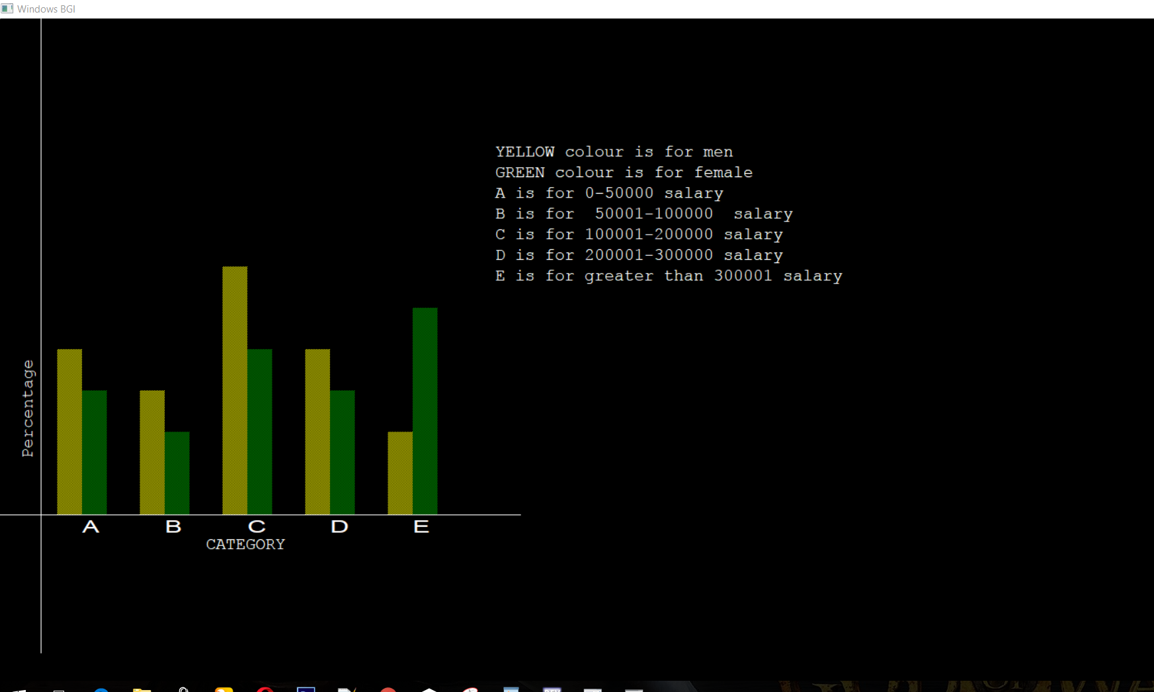

**OUTPUT 2:**



